Morgan Mackert

EEB 590: R for Ecologists and

Evolutionary Biologists

12/9/2016

**ANALYSIS OVERVIEW**

**Methods**

In order to assess native bee species richness and abundance, traps will be utilized at eight sites in central and eastern Iowa. Multiple trap types will be employed in an effort to capture the widest range of species possible, as each technique has been shown to target different species (Roulston et al., 2007). The distance between each site will be greater than the flight range of bees to ensure independent populations are being sampled.

Blue vane and pan traps will be used to collect bees. Because bees are readily influenced by weather conditions, these traps will be placed by 7:00am on days with weather conducive to bee activity: cloudless, sunny, calm (< 24 kph wind speeds), and warm (> 18ºC). Weather information will be retrieved from weather stations near each site. Within each strip, a sixty meter long transect will be measured and two blue vane traps filled with approximately an inch of soap and water solution will be placed at either end. Twelve pan traps, which are 96 mL plastic Solo® bowls, four of each white, fluorescent blue, and fluorescent yellow color, will be placed in random color order every five meters along the transect and then partially filled with a weak soap and water solution. Bamboo stakes of varying height will be used to adjust the height of the pans to that of the vegetation as the growing season progresses. Both the blue vane traps and the pan traps will remain deployed for six hours. Targeted and nontargeted sweep netting will be employed along the transect. Targeted sweeping is conducted to capture individual bees visiting flowers, whereas nontargeted sweeping through vegetation for a uniform amount of time and distance provides a consistent survey tool from site to site. Both sweeping methods will be conducted by two individuals along half of the transect (30m) for six minutes each for a total of 48 minutes of sweeping. Upon capture, individual bees will be placed in separate vials, the flower on which they were caught will be recorded, and pollen samples will be collected. Trapping and sweeping will begin in early May and will be repeated once per month through August for a total of five samples.

Floral resources will be assessed by placing a 1m x 1m quadrat randomly to either side of the transect every six meters for a total of ten quadrats. Percent cover of each blooming forb species within the quadrat will be estimated. Additional species in bloom found near, but not within, the strip will be recorded.

After collection, all specimens will be moved to the lab where they will be removed from ethanol, washed, dried, pinned with mouthparts pulled, and labeled. Identification will follow by utilizing online (Discover Life) and dichotomous (Mitchell [1960 and 1962] and Arduser [2016]) keys.

**Results**

In 2016, 3,022 bee specimens were collected across all of the sampling methods, with 434 bees being the greatest number collected during one sampling instance (Figure 1). A total of 75 blooming forb species were observed as well; 13 species was the greatest number observed at an individual site (Figure 2). Bee identification is still in progress, meaning that species richness has yet to be determined. In modeling the relationship between bee abundance, blooming forb species richness, date, and site, much overdispersion was observed, leading to the conclusion that this isn’t the best model for the data. When comparing bee abundance to blooming forb species richness during each sample period, a slight positive trend can be observed (Figure 3). However, there is a considerable amount of noise due to variables that have yet to be accounted for, such as weather condition and trap type. As of now, no definitive claims can be made concerning the results due to these unaccounted for variables. In the future, these variables will be considered and more concrete results will be obtained.

**Figures**

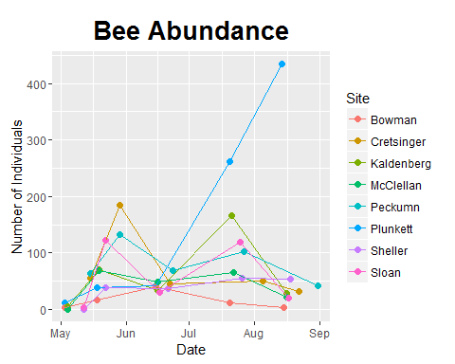

Figure 1: Number of bees collected from each site.

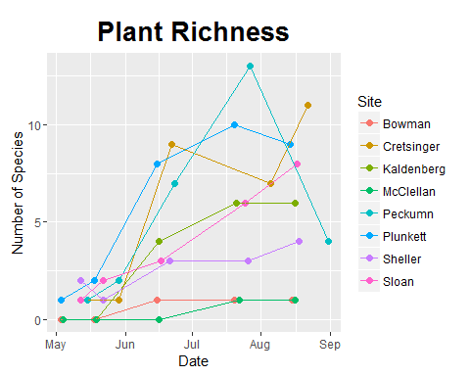

Figure 2: Number of blooming forb species present at each site.

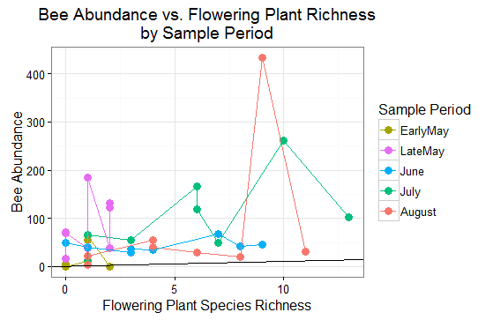

Figure 3: Number of collected bee specimens compared to number of blooming forb species present during each sample period in 2016. The individual points correspond to each site; there are eight points of each color, which represent each of the eight sites sampled during that particular sample period.